Git Branch and Merge

DXC DevOps

**Version 0.1**

**Michael Carey**

**2017**

|  |  |  |  |
| --- | --- | --- | --- |
| Issued | Amend By | Version | Revision Comments |
| 27/07/2017 | Michael Carey | 0.1 | Created |

# Prerequisites

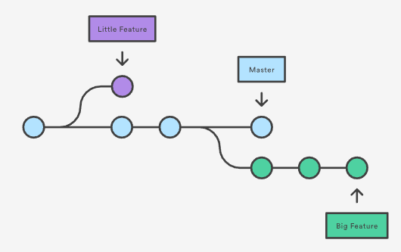A branch represents an independent line of development. You can think of them as a way to request a brand new working directory, staging area, and project history.

# Staging and deploying

|  |  |
| --- | --- |
|  | The first thing that should be done is to “git clone” or “git pull” your chosen Git Repository so that you have the most up to date version for branching. |
|  | If you type “git status” it will show you which branch you are currently using. It also highlighted this above your command line in blue. *Note: see circled areas in the below screen shot.*  git status  GitStatus |
|  | Now you can make your branch, type “git branch” then the name you want to give it e.g.: “git branch vf-uk-…..” *Note: Give a meaningful name,* ***NOT*** *like the example below*  git branch <branch name>  C:\Users\careymi\AppData\Local\Microsoft\Windows\INetCache\Content.Word\git branch.png |
|  | Type “git checkout” and the name you gave your branch. You can now freely edit without effecting the master version. *Note: The git bash terminal states that you have switched to that branch, see circled areas in the below screen shot.*  git checkout <branch name>  C:\Users\careymi\AppData\Local\Microsoft\Windows\INetCache\Content.Word\git checkout.png |
|  | If you type “git status” it will show you which branch you are currently using.  Git status |
|  | After finishing it’s time to add, commit and push the files on your branch back to the repo.  *Note: This is only pushing them back to the repository, you are not adding them back into the master version.* |
|  | Type “git add” and select the files you have edited or created.  git add <example files>  C:\Users\careymi\AppData\Local\Microsoft\Windows\INetCache\Content.Word\git add.png |
|  | Type “git commit –m” then add a meaningful message as to what you have done. Keep the message clear, concise and meaningful, everyone will see this on the git repository web interface. *Note: Make sure the message is in quotation (“message”) marks as exampled below.*  C:\Users\careymi\AppData\Local\Microsoft\Windows\INetCache\Content.Word\git commit.pnggit commit –m “<example message>” |
|  | After doing the previous “git commit” you can check to see if there are any outstanding by doing a “git status”. If there is nothing else to commit you will receive a message like the one below.  git status  C:\Users\careymi\AppData\Local\Microsoft\Windows\INetCache\Content.Word\git status after commit.png |
|  | Now you can push your edited branch to the git repository. Type “git push origin” and then the name of your branch.  git push origin <branch name>  C:\Users\careymi\AppData\Local\Microsoft\Windows\INetCache\Content.Word\git push origin.png |
|  | You will see the git window show the progress of the push. Once this is complete you will also see a URL for your branch in the git repository. *Note: See the circled below, you can copy and paste this in to your desired web browser.*  C:\Users\careymi\AppData\Local\Microsoft\Windows\INetCache\Content.Word\git push origin.png |
|  | C:\Users\careymi\AppData\Local\Microsoft\Windows\INetCache\Content.Word\git webinter.png Alternatively from that specific link, you can go to the git repository web interface and locate the branched from you repositories main page.  C:\Users\careymi\AppData\Local\Microsoft\Windows\INetCache\Content.Word\branches in interface.png |

End of Walkthrough